Brute Force - Searching & String Matching
Sequential Search, Brute Force String Matching
Dr. p.sriramya
Sequential Search
Question 1
Write a program to implement Sequential Search to find a given element in an array. Input:
Array: 12, 25, 8, 45, 32, 19, 50
Key: 32
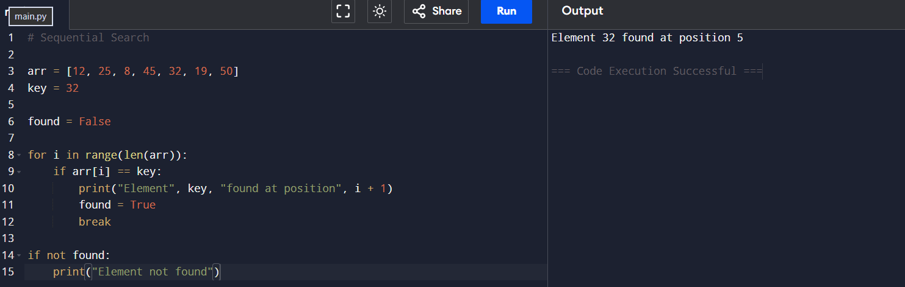

Output:
Element found at position 5
Number of comparisons = 5

Question 2
Implement Sequential Search for an unsuccessful search.
Input:
Array: 5, 10, 15, 20, 25, 30, 35
Key: 18
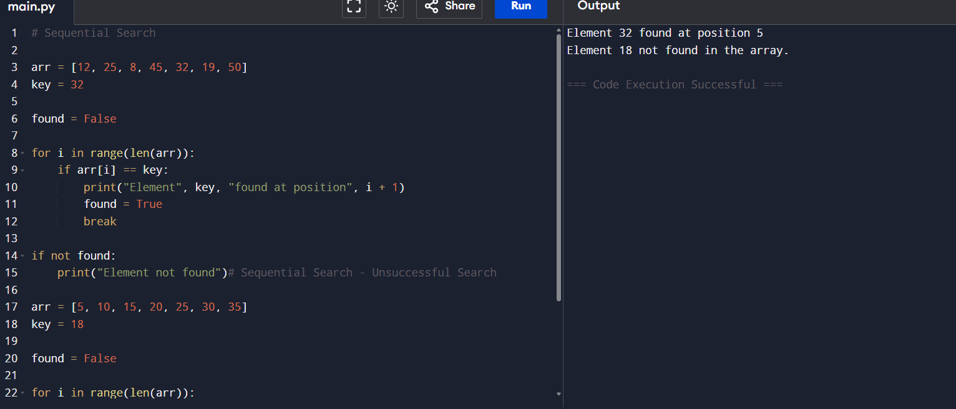

Output:
Element not found
Number of comparisons = 7

Question 3
Write a program to find the first occurrence of an element using Sequential Search. Input:
Array: 10, 25, 15, 25, 30, 25, 40
Key: 25
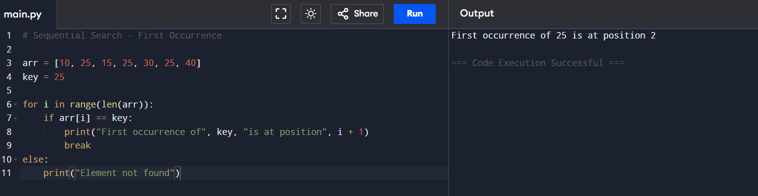

Output:
First occurrence at position 2
Question 4
Implement Sequential Search to find all occurrences of a given element. Input:
Array: 7, 12, 7, 25, 18, 7, 30, 7
Key: 7
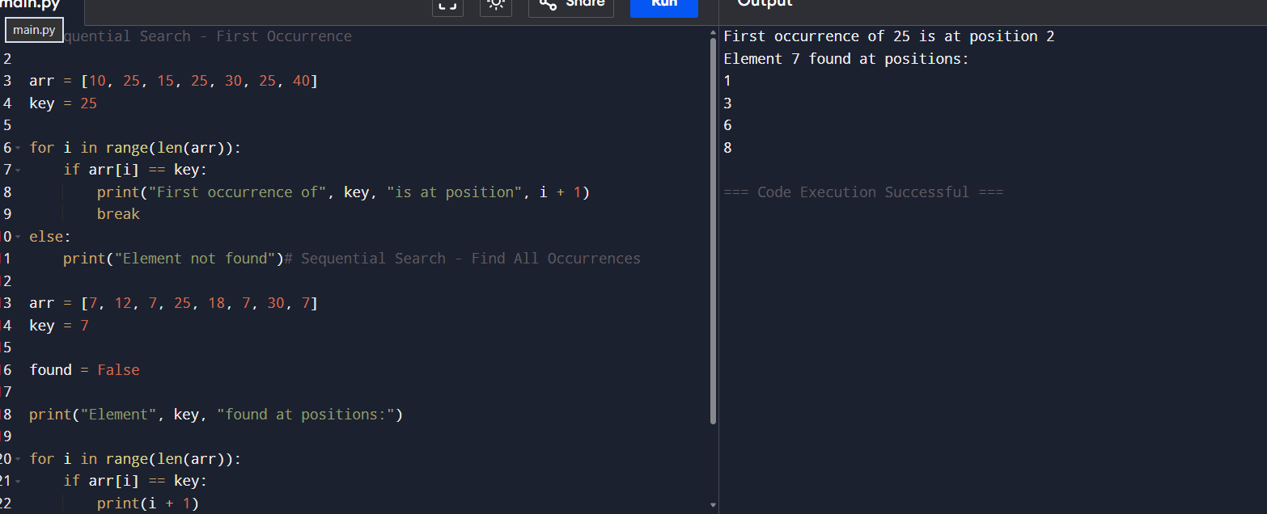

Output:
Occurrences at positions:
1, 3, 6, 8
Total occurrences = 4
Question 5
Write a program to count:
● Total comparisons
● Total matches
● Total mismatches
during Sequential Search.
Input:
Array: 3, 6, 9, 12, 15, 18, 21
Key: 15
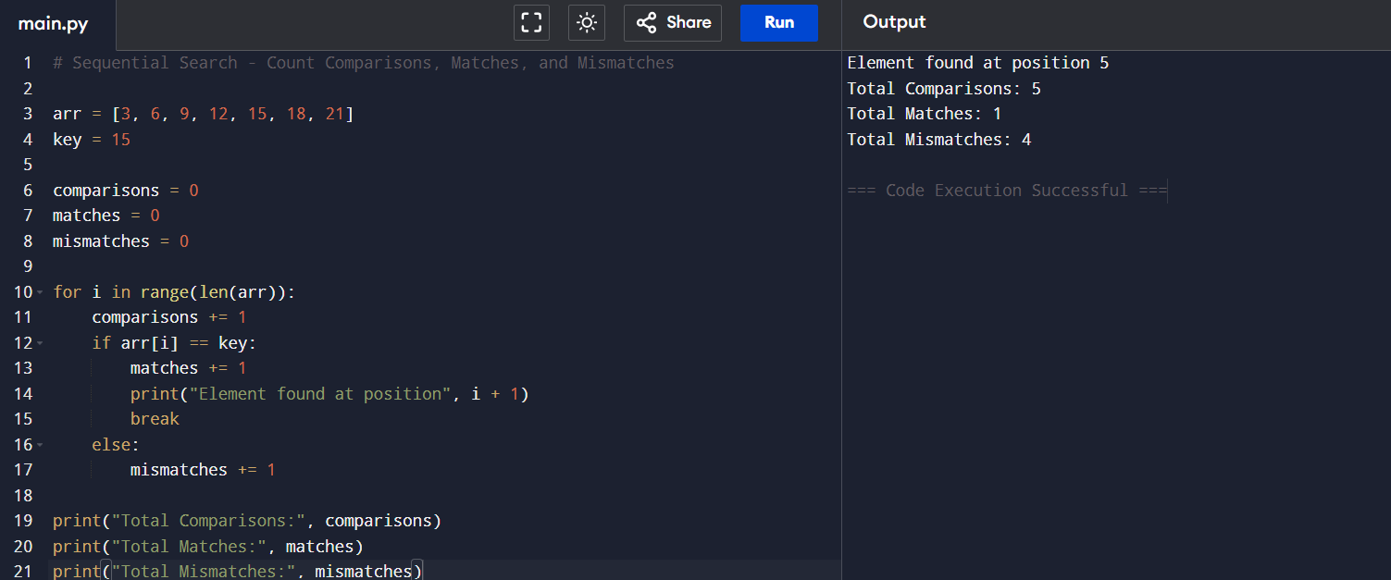

Question 6
Implement Sentinel Sequential Search and compare it with ordinary Sequential Search. Input:
Array: 14, 9, 22, 35, 18, 41, 27
Key: 18
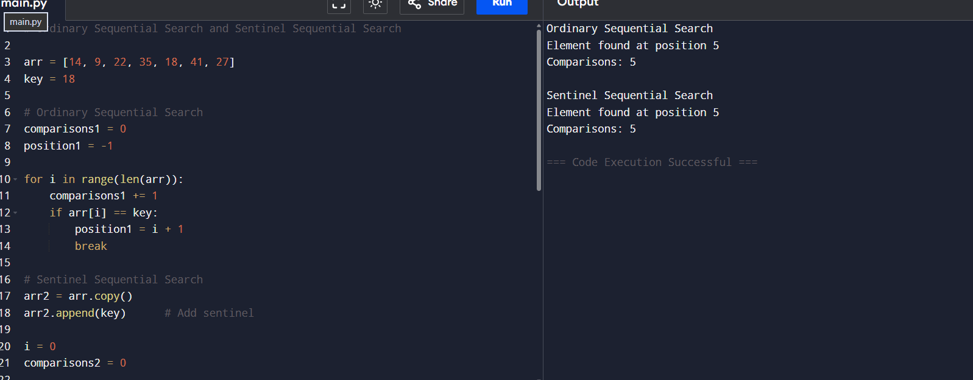

Output:
Position found
Comparison count
Question 7
Write a program to perform Sequential Search on an array of student register numbers. Input:
Register Numbers:
101, 102, 103, 104, 105, 106
Search Key: 104
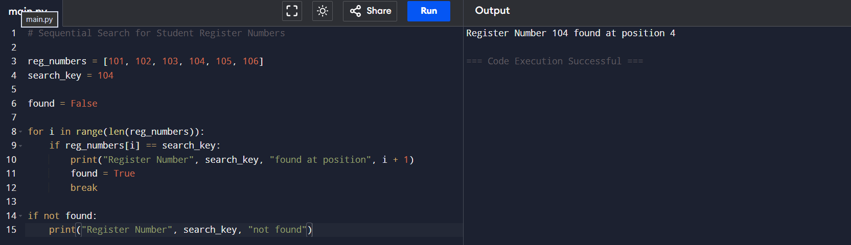

Output:
Register Number found at position 4
Question 8
Implement Sequential Search for string data.
Input:
Names:
Anu, Bala, Charan, Deepa, Esha, Farhan
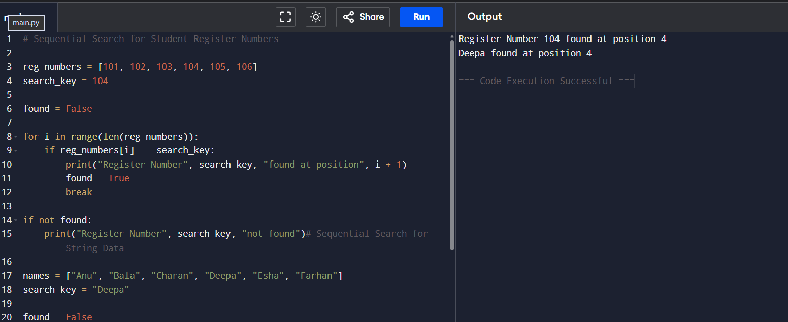

Search Name:
Deepa
Output:
Name found at position 4
Question 9
Write a program to perform Sequential Search on a 2-D matrix.
Input:
12 8 15
5 18 27
9 11 24
Key = 24
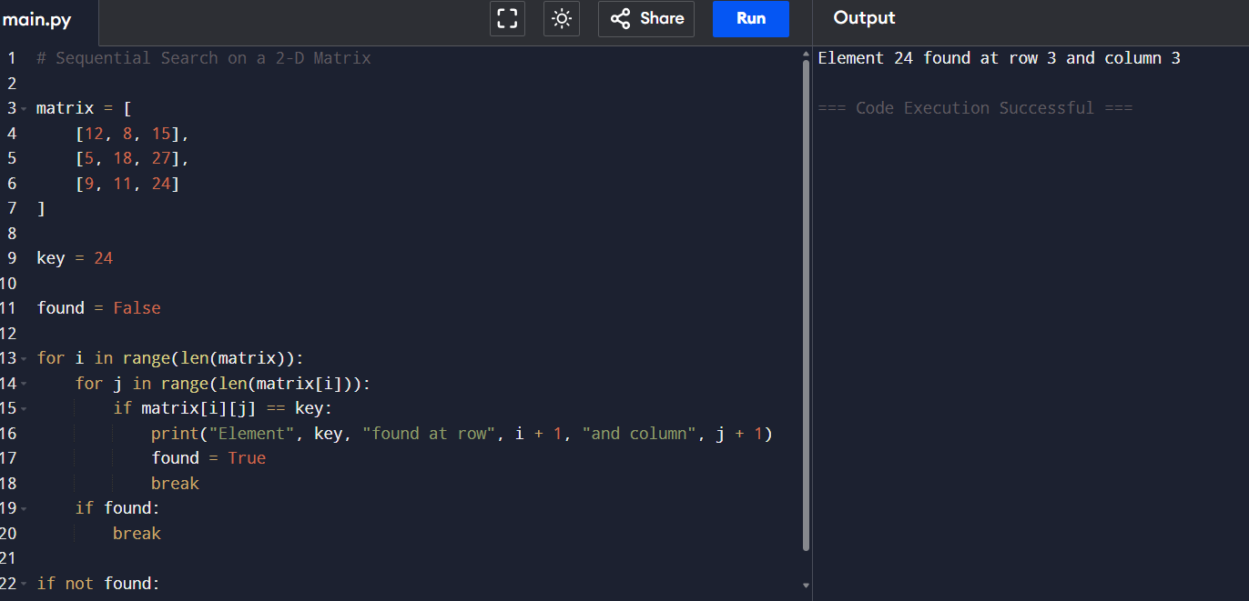

Output:
Element found at Row 3 Column 3
Question 10
Implement Sequential Search and analyze its performance. Input:
Array:
45, 23, 67, 12, 89, 34, 56, 78, 90, 11,
29, 73, 18, 64, 37
Search Keys:
73
18
100
Tasks:
1. Show each comparison.
2. Count comparisons for every search.
3. Identify best, average, and worst cases.
4. Determine:
○ Best-case complexity
○ Average-case complexity
○ Worst-case complexity
○ Space complexity

Brute Force String Matching
Question 1
Implement the Brute Force String Matching Algorithm to search for a pattern in a given text. Input:
● Text = "AABAACAADAABAABA"
● Pattern = "AABA"
Output:
● Position(s) where the pattern occurs.
● Total number of comparisons.
# Brute Force String Matching Algorithm
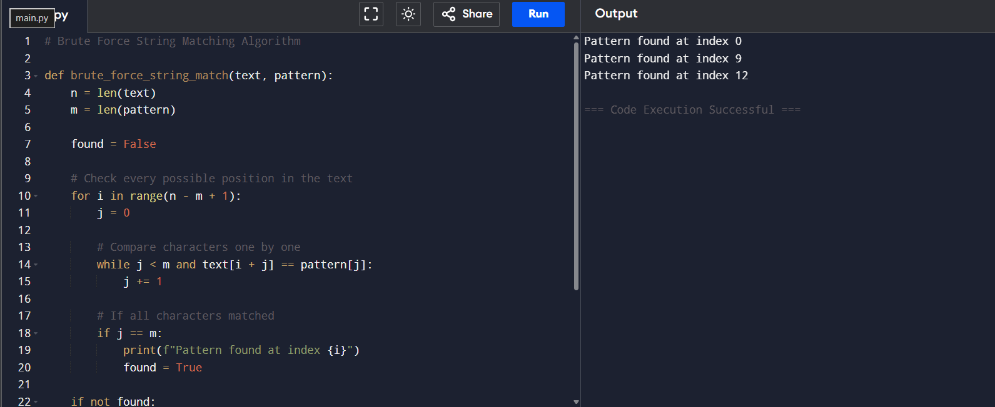

# Input
text = "AABAACAADAABAABA"
pattern = "AABA"

# Function Call
brute_force_string_match(text, pattern)

Question 2
Write a program to find all occurrences of a pattern in a text using Brute Force String Matching. Input:
● Text = "BANANABANANA"
● Pattern = "ANA"
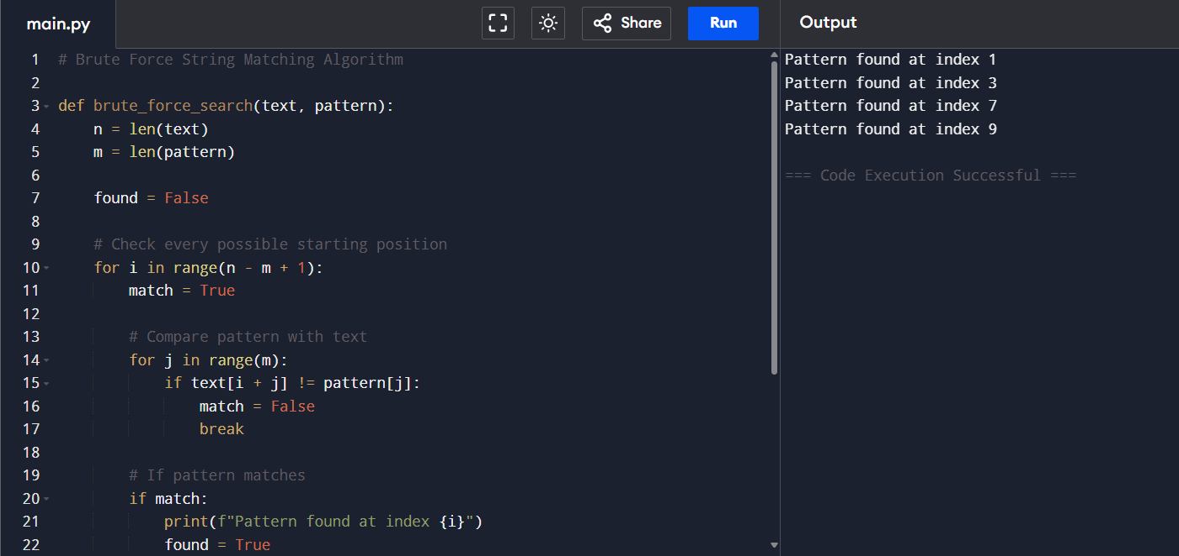
Output:
● Occurrences at positions 1, 3, 7, 9.

Question 3
Implement Brute Force String Matching and display the comparison table for each alignment.
Input:
● Text = "MISSISSIPPI"
● Pattern = "ISSI"
Output:
● Shift number
● Comparisons made
● Match/Mismatch result
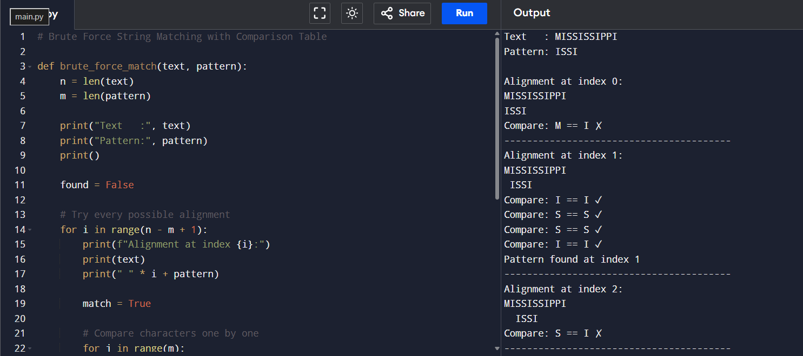

Question 4
Write a program to count:
● Total character comparisons
● Total matches
● Total mismatches
during Brute Force String Matching.
Input:
● Text = "ABABABABAB"
● Pattern = "ABAB"
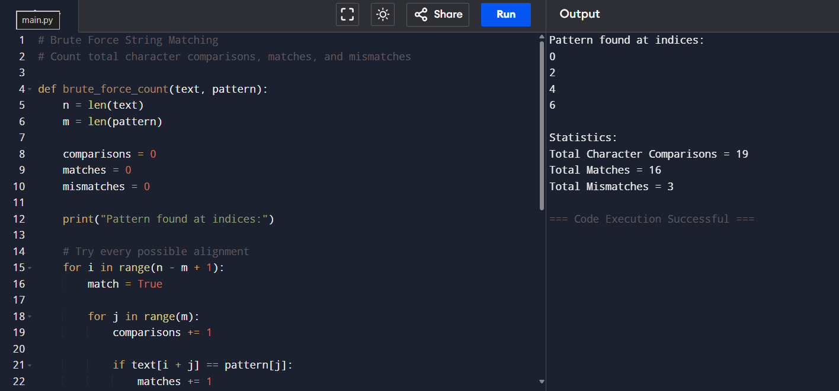

Question 5
Implement Brute Force String Matching and determine whether the search is:
● Best Case
● Average Case
● Worst Case
Input:
● Text = "AAAAAAAAAB"
● Pattern = "AAAAB"
Display the number of comparisons performed
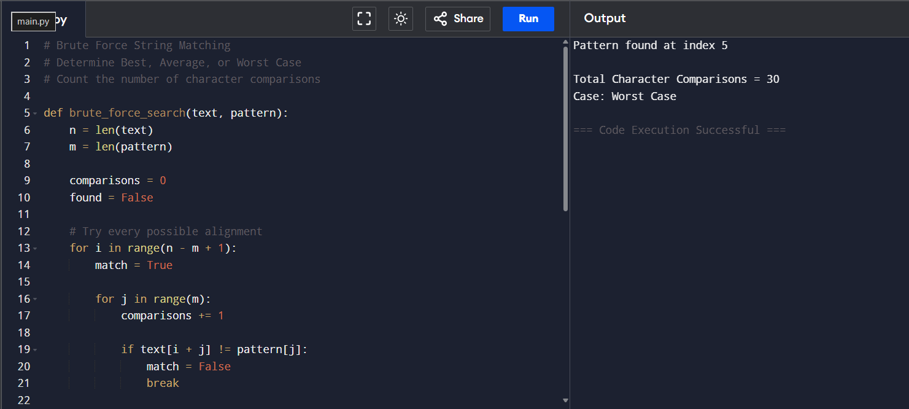.

Question 6
Write a program that searches for a pattern in a text and reports the first occurrence only using Brute Force String Matching.
Input:
● Text = "COMPUTERSCIENCE"
● Pattern = "SCI"
Output:
● First occurrence position
● Number of comparisons
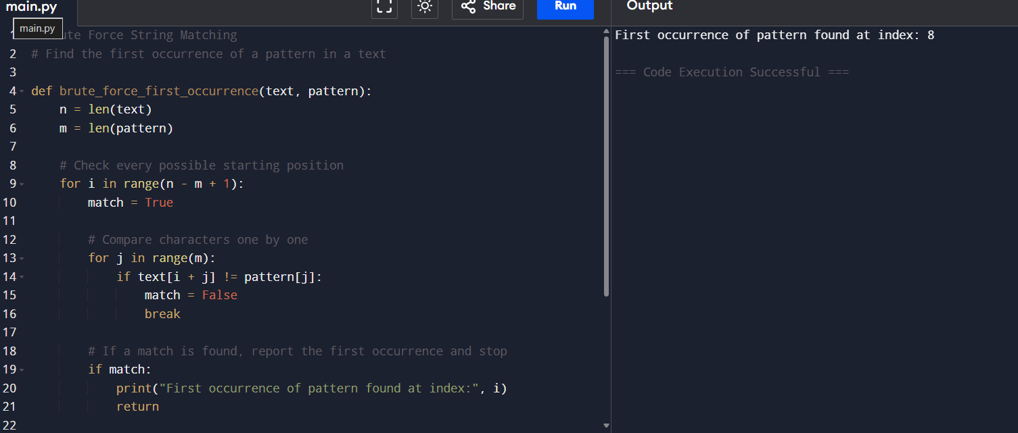

Question 7
Implement Brute Force String Matching for case-insensitive searching.
Input:
● Text = "DataStructuresAndAlgorithms"
● Pattern = "ALGORITHMS"
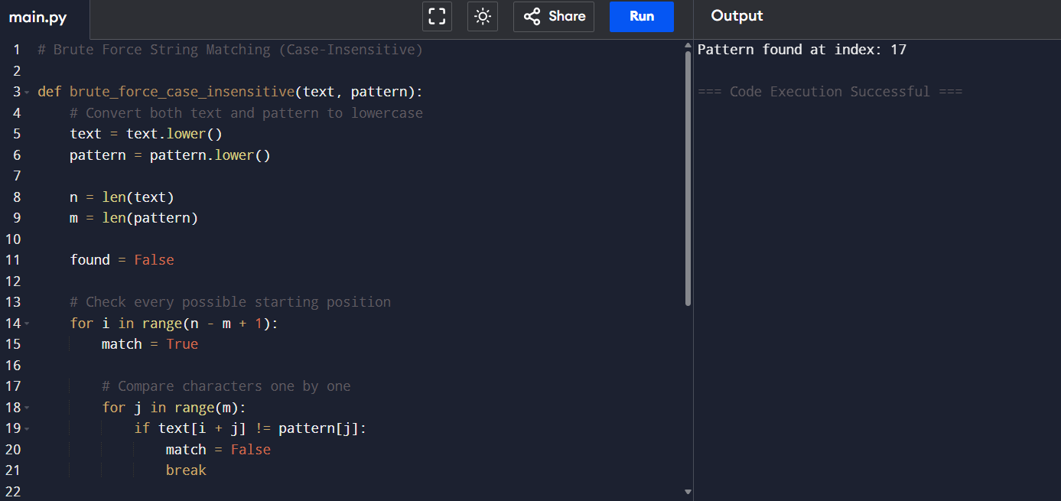
Output:
● Pattern found position

Question 8
Write a program to compare the execution of Brute Force String Matching for:
1. Successful search
2. Unsuccessful search
Input:
● Text = "PROGRAMMINGLAB"
● Pattern 1 = "LAB"
● Pattern 2 = "TEST"
Display the comparison count for both cases.
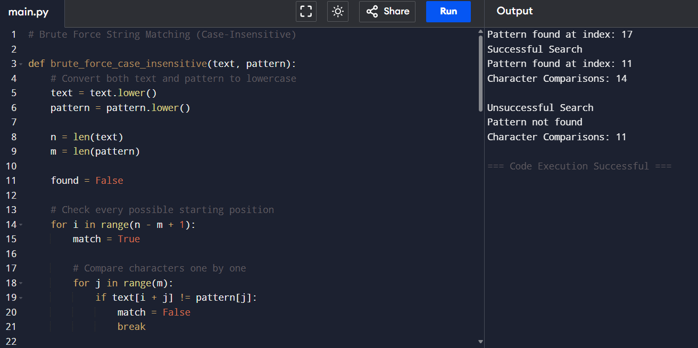

Question 9
Implement Brute Force String Matching and display every alignment of the pattern with the text. Input:
● Text = "ABCDABCABCDA"
● Pattern = "ABCDA"
Output:
● Alignment number
● Matching result
● Pattern occurrence positions
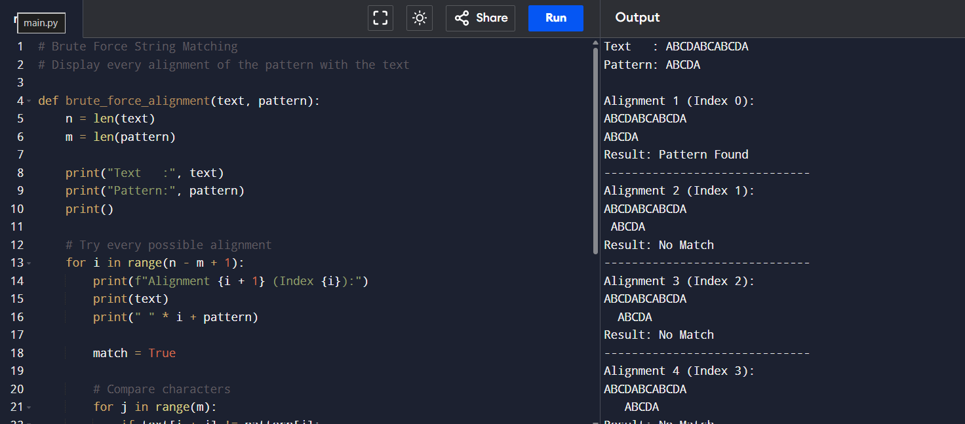

Question 10
Write a complete program for Brute Force String Matching and perform complexity analysis. Input:
● Text = "TTATAGATCTCGTATTCTTTATAGATCTCCTATTCTT" ● Pattern = "TATCTT"
Tasks:
1. Find all occurrences of the pattern.
2. Count total comparisons.
3. Display the shifting process.
4. Analyze:
○ Best-case complexity
○ Worst-case complexity
○ Space complexity
